

CENTRE FOR CONTINUING EDUCATION
in
TRANSPORTATION ENGINEERING
„IKKU” Ltd

_________________________________________________________________________________________________

The Centre „IKKU”, acting in co-operation with:

„PONTS • FORMATION • EDITION” SA - Formation Continue de l’ Ecole Nationale
des Ponts et Chaussées (ENPC)

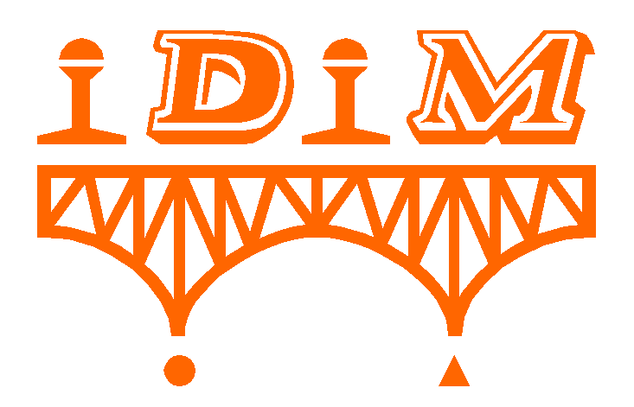
INSTITUTE OF ROADS AND BRIDGES
Warsaw University of Technology

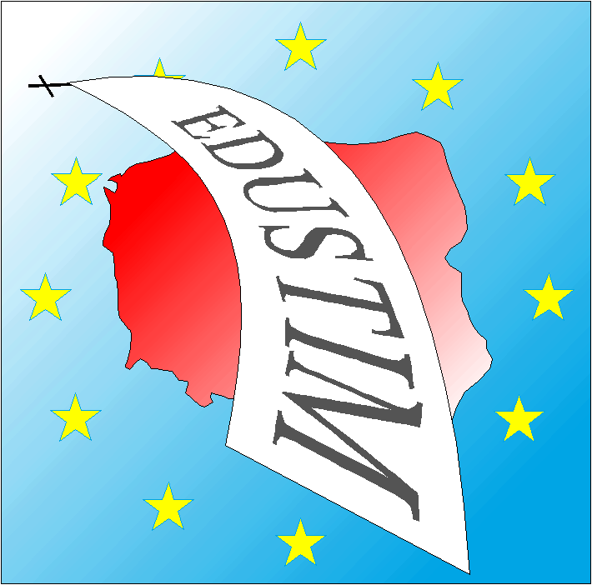

POLISH ASSOCIATION
for
CONTINUING ENGINEERING EDUCATION

„EDUSTIM”

recommends to the attention of institutions and companies:

- Training offer in the area of transportation engineering:

transport  roads  railways  bridges  airports

- Planning and programming of transportation infrastructure
- Management of transportation infrastructure and traffic management
- Design, construction and maintenance of transportation systems and structures

for the professional updating and development in:

- management of transportation systems and projects
- traffic management and traffic safety
- planning, programming and designing
- organisation and technology of construction works
- economical, technical and environmental studies
- technical regulations and requirements
- computer assisted engineering
- and other

being of interest of:

- state and local administration
- public and private companies and institutions
- consulting organisations
- transport operators

- Consulting in the area of training engineering:

- design, development and maintenance of training systems
- identification of training needs, planning, implementation and evaluation of training activity
- design, delivery and assessment of training actions

Private Society Ltd with the initial capital of 44,000 PLN; Site: ul. Polinezyjska 3/40, PL - 02 777 Warszawa; Register: KRS Nr
0000037599, REGON 013072050, NIP 951-18-45-625; Tel/Fax (autom.): +(48)(22) 4462717; E-mail: ikku@acn.waw.pl;
Bank: ING BSK, O/Warszawa, Filia Nowowiejska 5, Nr 18 10501038 10000022 06332732; WWW: http://free.polbox.pl/i/ikku;
President of the Board: Roman Nagórski; Tel./Fax: +(48)(22) 8255560, Mobile: + 603682047, E-mail: R.Nagorski@il.pw.edu.pl

